Cross-quantilogram: EURUSD and GBPUSD
Method 20 / daily log returns / expanding quantiles / Alpari D1 full available history

Study setup
Logical pair: EURUSD , GBPUSD
Broker symbols: EURUSD_i , GBPUSD_i
Snapshot: 2026-11-03_majors_alpari_D1
Timeframe: D1
Matched return window: 1999-01-05 to 2026-11-02 (UTC bar dates)
Matched return count n: 7202
Dropped unfinished last bar dated 2026-11-03 UTC after a tick-volume check against the prior complete day.
Quantiles: expanding window, min history 252 days
tau in [0.05, 0.2]; k=0..10; headline tau=0.05, k=1
Complete matched rows (Excel): EURUSD-GBPUSD_CQ_D1.xlsx
Complete matched rows (HTML table): EURUSD-GBPUSD_CQ_D1_data.html

Method carried forward
The cross-quantilogram rho_tau(k) measures linkage among centered quantile-hit indicators of matched daily log returns of close, ln(close_t / close_t-1). Quotes are not inverted. At each date t, the tau-quantile uses only returns through t (expanding window) after a minimum history of 252 days. Hits are h_t = 1(r_t < q_t) - tau. rho_tau(k) is the normalized cross-product of h_x,t with h_y,t+k. Levels tau in {0.05, 0.20} and lags k=0..10 are pre-specified; headline is tau=0.05, k=1 both directions. Same-sample Pearson r is a side check. This is not causation and not a trading signal.

Results (headline)
rho_EURUSD->GBPUSD(tau=0.05,k=1): 0.058094
rho_GBPUSD->EURUSD(tau=0.05,k=1): 0.025467
rho_EURUSD->GBPUSD(tau=0.20,k=1): 0.036617
rho_GBPUSD->EURUSD(tau=0.20,k=1): 0.011694
Pearson r: 0.641738

CQ table (tau=0.05)
k | rho_EURUSD_to_GBPUSD | n_EURUSD_to_GBPUSD | rho_GBPUSD_to_EURUSD | n_GBPUSD_to_EURUSD
0 | 0.29736182 | 6951 | 0.29736182 | 6951
1 | 0.05809353 | 6950 | 0.0254669 | 6950
2 | 0.07621108 | 6949 | 0.03633372 | 6949
3 | 0.03995024 | 6948 | 0.04720074 | 6948
4 | 0.04356683 | 6947 | 0.03269098 | 6947
5 | 0.05443411 | 6946 | 0.04355817 | 6946
6 | 0.04717486 | 6945 | 0.03629881 | 6945
7 | 0.06529314 | 6944 | 0.04716623 | 6944
8 | 0.05440843 | 6943 | 0.03265594 | 6943
9 | 0.05077442 | 6942 | 0.02539628 | 6942
10 | 0.02901293 | 6941 | 0.03263841 | 6941

Conclusion
Headline tau=0.05, k=1 for EURUSD and GBPUSD: rho_EURUSD->GBPUSD = 0.0581; rho_GBPUSD->EURUSD = 0.0255. At tau=0.20, k=1: 0.0366 and 0.0117. Same-day tau=0.05 rho(k=0) = 0.2974. Pearson r = 0.6417. This is quantile-hit linkage, not a trading signal.

Charts
Daily closes

Daily log returns

Cross-quantilogram tau=0.05
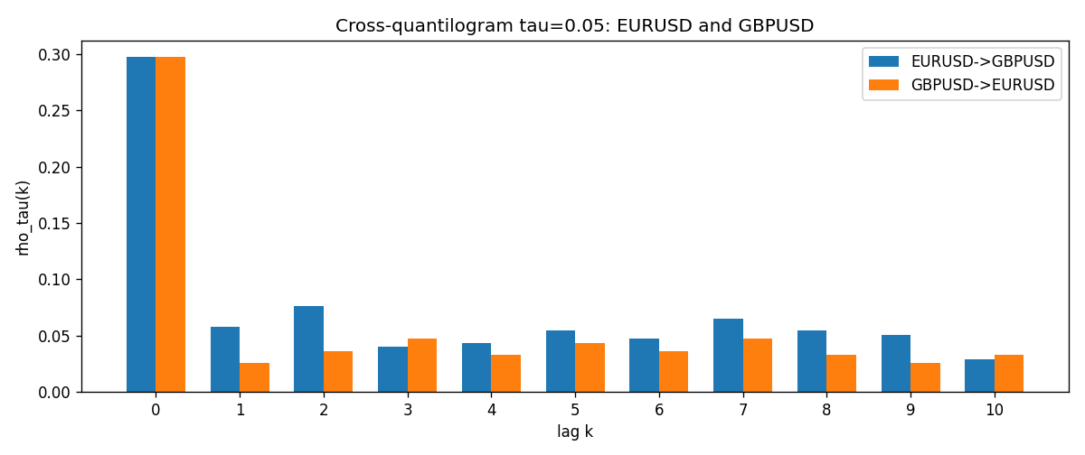

Data report
Matched rows and the CQ sheet are in the sibling Excel workbook named EURUSD-GBPUSD_CQ_D1.xlsx. Embedding all rows as a Word table is impractical; this file holds column summaries and the first and last 15 matched rows.
Columns: time, EURUSD_open, GBPUSD_open, EURUSD_high, GBPUSD_high, EURUSD_low, GBPUSD_low, EURUSD_close, GBPUSD_close, EURUSD_tick_volume, GBPUSD_tick_volume, EURUSD_spread, GBPUSD_spread, EURUSD_real_volume, GBPUSD_real_volume, EURUSD_log_return, GBPUSD_log_return, EURUSD_h_t005, GBPUSD_h_t005
Column summaries (matched calculation rows)
column | count | mean | std | min | 25% | 50% | 75% | max
EURUSD_open | 7202 | 1.1812936 | 0.15087968 | 0.8272 | 1.086065 | 1.166145 | 1.293925 | 1.5995
GBPUSD_open | 7202 | 1.5160822 | 0.2182507 | 1.06854 | 1.325005 | 1.51141 | 1.63166 | 2.1066
EURUSD_high | 7202 | 1.1864255 | 0.15147858 | 0.8326 | 1.0901775 | 1.17127 | 1.2992275 | 1.6038
GBPUSD_high | 7202 | 1.5223773 | 0.21881719 | 1.08366 | 1.329795 | 1.51815 | 1.63839 | 2.1161
EURUSD_low | 7202 | 1.1762813 | 0.15020267 | 0.8227 | 1.0819975 | 1.162535 | 1.288315 | 1.5865
GBPUSD_low | 7202 | 1.5097565 | 0.21747799 | 1.03518 | 1.3195075 | 1.503295 | 1.6243825 | 2.0983
EURUSD_close | 7202 | 1.1813323 | 0.15085599 | 0.8267 | 1.0860025 | 1.166105 | 1.2939475 | 1.5997
GBPUSD_close | 7202 | 1.5161468 | 0.21820921 | 1.06879 | 1.325125 | 1.511325 | 1.632095 | 2.1065
EURUSD_tick_volume | 7202 | 102990.53 | 173401.83 | 218 | 9388.25 | 52708 | 99433.75 | 1471626
GBPUSD_tick_volume | 7202 | 94813.509 | 153540.37 | 62 | 9988.5 | 52886.5 | 91789.25 | 1273370
EURUSD_spread | 7202 | 19.400444 | 16.577153 | 0 | 8 | 12 | 30 | 50
GBPUSD_spread | 7202 | 26.974313 | 19.194125 | 0 | 11 | 20 | 50 | 50
EURUSD_real_volume | 7202 | 4.0233049e+10 | 1.6674277e+11 | 0 | 0 | 0 | 0 | 3.6149665e+12
GBPUSD_real_volume | 7202 | 3.5555961e+09 | 8.4432361e+10 | 0 | 0 | 0 | 0 | 2.4038164e+12
EURUSD_log_return | 7202 | -7.71e-06 | 0.00580133 | -0.03123819 | -0.00324586 | 0 | 0.00325471 | 0.03433183
GBPUSD_log_return | 7202 | -2.587e-05 | 0.00564523 | -0.08388241 | -0.00313091 | 3.124e-05 | 0.00317757 | 0.03112653
EURUSD_h_t005 | 6951 | -0.01676737 | 0.17925636 | -0.05 | -0.05 | -0.05 | -0.05 | 0.95
GBPUSD_h_t005 | 6951 | 0.00121565 | 0.22045317 | -0.05 | -0.05 | -0.05 | -0.05 | 0.95
First 15 matched rows (selected columns)
time | EURUSD_log_return | GBPUSD_log_return | EURUSD_h_t005 | GBPUSD_h_t005
1999-01-05 | -0.0048360507 | -0.0028966287 | nan | nan
1999-01-06 | -0.011547966 | -0.00060452184 | nan | nan
1999-01-07 | 0.0076280636 | -0.002118709 | nan | nan
1999-01-08 | -0.010902799 | -0.0058954193 | nan | nan
1999-01-11 | -0.007103287 | -0.0056851331 | nan | nan
1999-01-12 | 0.0045103728 | 0.0022657001 | nan | nan
1999-01-13 | 0.010845346 | 0.0091330396 | nan | nan
1999-01-14 | 0 | 0.0019376331 | nan | nan
1999-01-15 | -0.010153245 | -0.0017558204 | nan | nan
1999-01-18 | 0.0036256946 | 0.0012112405 | nan | nan
1999-01-19 | -0.00017235436 | 0.0018745281 | nan | nan
1999-01-20 | -0.0031939256 | -0.0049053846 | nan | nan
1999-01-21 | 0.0030215416 | 0.0031518998 | nan | nan
1999-01-22 | -0.0012075213 | 0.0024781662 | nan | nan
1999-01-25 | -0.0030251979 | 0.0012066366 | nan | nan
Last 15 matched rows (selected columns)
time | EURUSD_log_return | GBPUSD_log_return | EURUSD_h_t005 | GBPUSD_h_t005
2026-10-13 | 0.0037402957 | 0.0036434319 | -0.05 | -0.05
2026-10-14 | -0.0037582255 | -0.0049164679 | -0.05 | -0.05
2026-10-15 | 0.0056053107 | 0.0065976411 | -0.05 | -0.05
2026-10-16 | 0.0017724895 | 0.0037592051 | -0.05 | -0.05
2026-10-19 | -0.0025394633 | -0.0017500314 | -0.05 | -0.05
2026-10-20 | 0.0023881672 | 0.0055923442 | -0.05 | -0.05
2026-10-21 | -0.00032046717 | 0.0012476328 | -0.05 | -0.05
2026-10-22 | -0.0015949606 | 0.00022396082 | -0.05 | -0.05
2026-10-23 | -0.001338521 | -0.0021146949 | -0.05 | -0.05
2026-10-26 | -0.0022706559 | -0.0024340661 | -0.05 | -0.05
2026-10-27 | -0.004152342 | -0.0023648393 | -0.05 | -0.05
2026-10-28 | 0.0022262927 | 0.0015771808 | -0.05 | -0.05
2026-10-29 | 0.0022571351 | 0.0035881935 | -0.05 | -0.05
2026-10-30 | -0.0011458446 | 0.0013450605 | -0.05 | -0.05
2026-11-02 | 0.002120569 | 0.0010971256 | -0.05 | -0.05

